LDAP

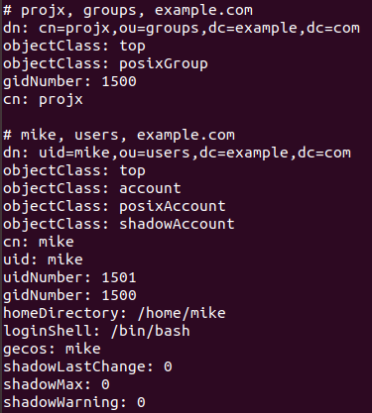

Ran ldapsearch -x | less to observe entries in directory